MODULE | CT042-3-1-IDB Introduction to Database
ASSIGNMENT | 1 - Group Coursework
HAND OUT DATE | 7th April 2025
SUBMISSION DATE | Part 1 – 25th May 2025  Part 2 – 22nd June 2025

MODULE LEARNING OUTCOMES:
- Apply redundancy control in designing a database.
- Demonstrate a database solution using an appropriate tool based on a case study.

CASE STUDY:

Scenario:

‘Delicious Pizza’ App for Ordering and Delivery Management
Delicious Pizza is a rapidly growing pizza restaurant chain with multiple branches across the city. They have hired you to develop the database for an application that allows customers to order pizzas and manage their deliveries seamlessly.

Step 1: Sarah Places an Order
It’s a busy Friday evening, and Sarah, a regular customer, opens the Delicious Pizza app to order dinner. She logs in using her customer account. The app automatically detects her location and displays the nearest restaurant branch, complete with its address and contact information. Sarah browses the menu, which lists all the items offered by the restaurant. She selects a large Hawaiian pizza and garlic bread, adds them to her cart, and proceeds to checkout. The app displays the total amount of her order in the cart. At the checkout, Sarah confirms her delivery address and pays for the order using her saved credit card. The app allows her to place multiple orders, but each order must be paid for separately.

Step 2: Restaurant Receives the Order
The selected restaurant receives the order instantly through the app. Each restaurant can handle multiple orders simultaneously. Eric, the restaurant staff member accepts the order and records it into the system along his ID. While one staff member can handle many orders, each order is assigned to only one staff member. Once the pizza is prepared, Eric updates the order status to "Ready for Pickup" in the system.

Step 3: Delivery Assignment and Preparation
Meanwhile, the app assigns the order to Ahmed, a delivery person. Ahmed is one of many delivery personnel working for Delicious Pizza. Ahmed can handle multiple deliveries at a time. Ahmed receives a notification on his app with the delivery details, including the pickup time and delivery address. He heads to the restaurant to collect the order. As soon as Ahmed picks up the order, the app updates the order status to "Out for Delivery", which can be seen by Sarah as well.

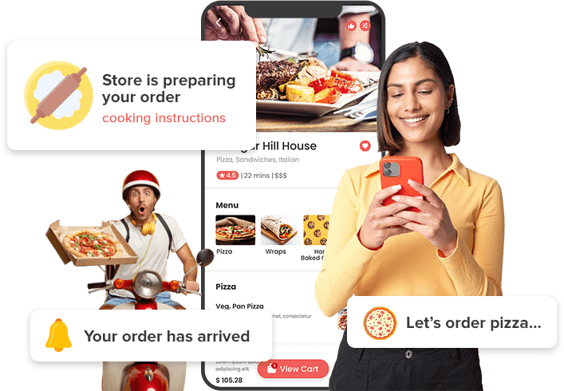
Figure-1 Pizza Ordering Advertisement, for illustration purpose only
Source; https://www.elluminatiinc.com/online-ordering-system/pizza/

Step 4: Real-Time Tracking and Delivery
Sarah, eager to track her food, opens the app and sees Ahmed’s real-time location on the map, thanks to the app’s real-time location tracking feature. Each delivery is associated with one real-time location at any given time. Sarah also receives a notification confirming that her order is on the way. Sarah can receive multiple notifications, one for each of their orders. Ahmed arrives at Sarah’s house and hands over the pizza. Sarah marks the order as delivered in the app, and the order status is updated to "Delivered."

Step 5: Post-Delivery Feedback
A few hours later, Sarah receives another notification, this time asking her to rate her experience. She opens the app and writes a review, giving the restaurant 5 stars for Delicious Pizza and 5 stars for Ahmed’s prompt delivery. Customers like Sarah can write multiple reviews for their orders.

TASKS
In this Coursework, you are required to design, implement, and document a database system for the above system.

Part-1 – Analysis and Design (40%)
- Database and Database Management System
  - Discuss the disadvantages of file-based system, relate your discussion to the case study
  - Discuss the advantages of Database and DBMS, functions of DBMS, relate your discussion to the case study
- Business Rules & Normalization
  - Generate a list of business rules for the system
  - Provide an example of UNF according to case study, then perform normalization up to 3NF clearly showing all the steps with explanation
- Entity Relationship Diagram (ERD)
  - Design the database using proper notation, draw the ERD with any suitable tools such as Visio. All entities, attributes, relationships and constraints should be shown clearly.

Part-2 – Implementation (60%)
- Database Schema
  - Re-submit the Entity-Relationship Diagram (ERD), you may make changes to it.
  - Generate the database diagram using the DBMS.
- SQL – Data Definition Language (DDL)
  - Create all necessary tables, ensuring the use of appropriate data types and constraints.
  - Document and include all SQL statements used for table creation.
  - Capture and include screenshots of the created tables along with their populated data.
- SQL – Data Manipulation Language (DML)
  - Develop and write SQL queries to address the requirements as in Attachment-1.
  - Provide screenshots of the SQL query statements along with their executed results.

GENERAL REQUIREMENTS:
In this assignment you are required to:
- Work a group of 3-5 members.
- Design and implement a solution to a business problem.
- Implement the solution using any Enterprise DBMS.
- Document the solution as set out in the assignment requirements.
- Submit the document online according to the date and time given below.
- Each group member is required to participate in all tasks / discussions together.
- Presentation schedules will be published at a later date through MS TEAMS.

Note: It is acceptable for discrete activities of this assignment to be undertaken by individual group members. However, it is essential that all group members understand the presentation in its entirety. At the end of the demonstration your group will be asked a series of questions to explore your understanding and analysis of the given problem. Responses to these questions such as “I don’t know because I didn't work on that part of the assignment” are not acceptable and will result in a penalty for either the entire group or specific individual(s).

MARKS ALLOCATION

Part | Assessment Criteria: | Marks Allocation | Online  Submission Date
Part-1 – Analysis and Design  - Database and Database Management System  - Business Rules & Normalization  - Entity Relationship Diagram |  | 8%  12%  20% | Week 8
Part-2 – Implementation  - Database Schema  - SQL-Data Definition Language (DDL)  - SQL-Data Manipulation Language (DML) |  | 18%  12%  30% | Week 12

End.
ATTACHMENT-1
The below questions need to be presented into Section 6. You may need to manipulate your database to comply with the below questions.

- Write an SQL query to find customers who placed orders with a total amount greater than $50. Sort the list by descending order

- Write an SQL query to find all orders placed between '2023-10-01' and '2023-10-31' with a delivery status of "Delivered".

- Write an SQL query to find the minimum order value for each customer.

- Write an SQL query to find all menu items ordered by a customer named "Sarah".

- Write an SQL query to find the average rating given to each restaurant.

- Write an SQL query to find customers who ordered "Hawaiian Pizza".

- Write an SQL query to calculate the total revenue generated from deliveries handled by each delivery person.

- Write an SQL query to find the top-selling menu item (the item ordered the most).

- Write an SQL query to find customers who placed orders in October 2024.

- Write an SQL query to find customers who have not placed any orders.

- List all orders with customer names and restaurant addresses. Only show records where the customer and restaurant exist.

- Display all deliveries, including those without assigned delivery personnel, showing the customer name and delivery person.

- Find customers who gave a 5-star rating, and match with the restaurant and delivery person reviewed.

- Show all delivery personnel and the total orders they handled, including those with zero deliveries.

- Show all customers with their total spending. Include customers who haven't placed any orders.

End.

